**Engineering a better experience for sick kids**

5 March 2018

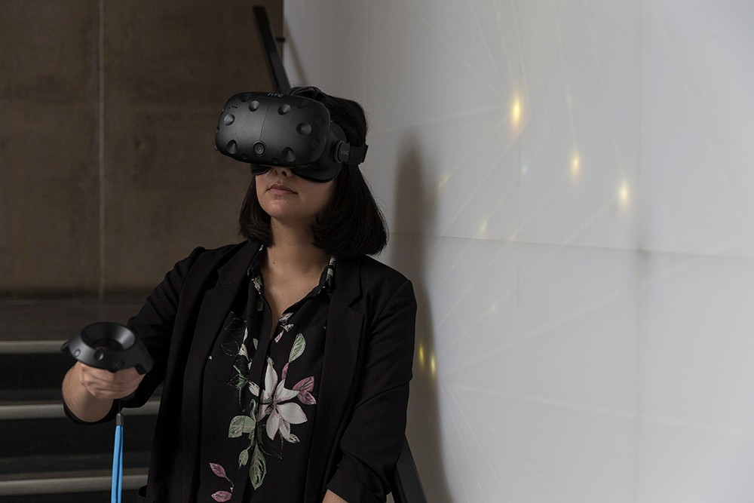

Ahmadpour is working with clinicians at Westmead to design virtual and augmented reality experiences to distract kids in hospital.

Iranian-born experiences designer, Dr Naseem Ahmadpour, country-hopped from Sweden to Canada before joining Sydney in 2016, and it has given her a unique edge in her field.

“Living in different continents from year to year is not the easiest thing to do, but it’s definitely been an advantage in my field. If you’re going to design for people, you need to understand them, and their culture.”

Naseem, an early-career researcher from the [Sydney School of Architecture, Design and Planning](http://sydney.edu.au/architecture/), has just kicked off a new project at Westmead, developing virtual and augmented reality experiences to distract young children (aged six and up) while they’re having medical procedures – such as stitches, vaccinations and before surgery.

Working in collaboration with paediatricians and anaesthetists at the Children’s Hospital at Westmead, Naseem is gearing up to research the virtual and augmented reality experiences already available in this space, figuring out what’s working and what’s not.

From there, the plan is to run focus groups for children, parents and clinicians, to see what each of these groups need, before developing interactive technologies and testing them in two clinical settings – induction of anaesthesia before paediatric surgeries and vaccination of children with severe needle phobia that prevents them completing their required immunisation schedule.

Once developed, the technologies could be rolled out in emergency and outpatient departments as well as during day surgery procedures and radiology scans.

“We’re not sure what form the tools will take yet,” Naseem says. “They could include a completely immersive experience, where the child wears virtual reality goggles and is transported to another world, or they could include an iPad app or a physical object that distracts the child without isolating them from their environment entirely.”

Whatever form they take, this will be the first time such technologies have been designed in collaboration with children, so Naseem says the efficacy is likely to be higher than current tools.

There’s strong evidence to suggest that virtual reality can be very beneficial in medical environments. [One recent study showed](http://www.vrpain.com/) that burn patients who used a virtual reality app that transported them into a field of snow felt cooler and experienced less pain.

“My intention is to make an impact, to make a difference in people’s lives. Working with industry, and clinicians who are at the coalface, makes sense because it allows you to see how your research is applied in practice and translate it so that it can be used every day by those who need it.”

# Virtual reality to take sick kids far from their hospital beds

By Carla Dengate

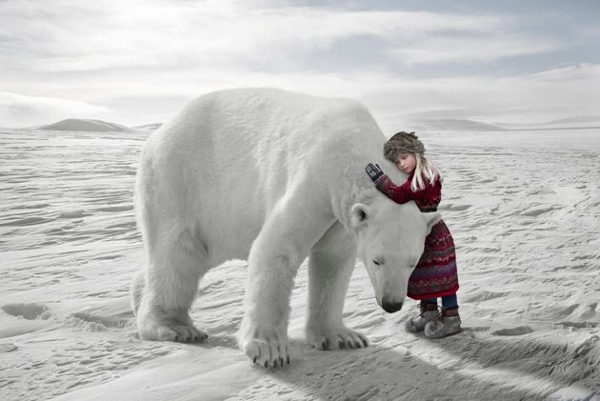Virtual reality has the ability to take sick children from their hospital beds to far-away worlds, under the sea or on a rollercoaster, so where do they want to go?

"The young kids at The Alfred's oncology ward told us they just wanted to be 'anywhere but here'," virtual reality maker Trent Clews-De Castella told The Huffington Post Australia.

He is co-creator of virtual reality company Phoria, that is creating experiences specifically for sick children in hospitals, thanks to a [new grant from the Murdoch Childrens Research Institute](https://www.mcri.edu.au/news/winners-announced-unique-digital-health-program).

"We're realising we don't need to reinvent the wheel in terms of experiences so we're looking at what's proven in the medical space to have therapeutic benefits," Clews De-Castella said.

"Right now we're looking at creating animal-assisted therapy experiences working with Zoos Victoria, as well as things like breathing exercises."

Children could pop on a pair of inexpensive VR goggles and find themselves interacting with a panda or a giraffe.

"There's good evidence that kind of distraction is good for pain management and reducing anxiety," he said.

Clews-De Castella said the project was indebted to one special family, the Johns from Victoria.

"We had created a VR experience for the TV show The Block and we had a call from a family who got in touch with the producers to say their daughter was a huge fan of the show but that she was also very sick and was there any way we could bring the show to Beccky.

"We went to the hospital with the VR experience and she loved it.

"Afterwards, her father Paul told us how the doctors had exclaimed that the experience had given her such a boost. He said this was such a simple experience -- just walking through an apartment -- and had we considered making something specific?"

Despite two kidney transplants from mum and dad, Beccky died of Hodgkins Lymphoma, but her joy at VR has spawned this project, which, if all goes according to plan, will be enriching lots of young peoples' hospital experiences.

**Related stories**

<https://www.vrbeginnersguide.com/virtual-reality-transporting-sick-kids-to-outer-space/>

<https://www.huffingtonpost.com.au/2016/11/14/virtual-reality-to-take-sick-kids-far-from-their-hospital-beds_a_21606003/>